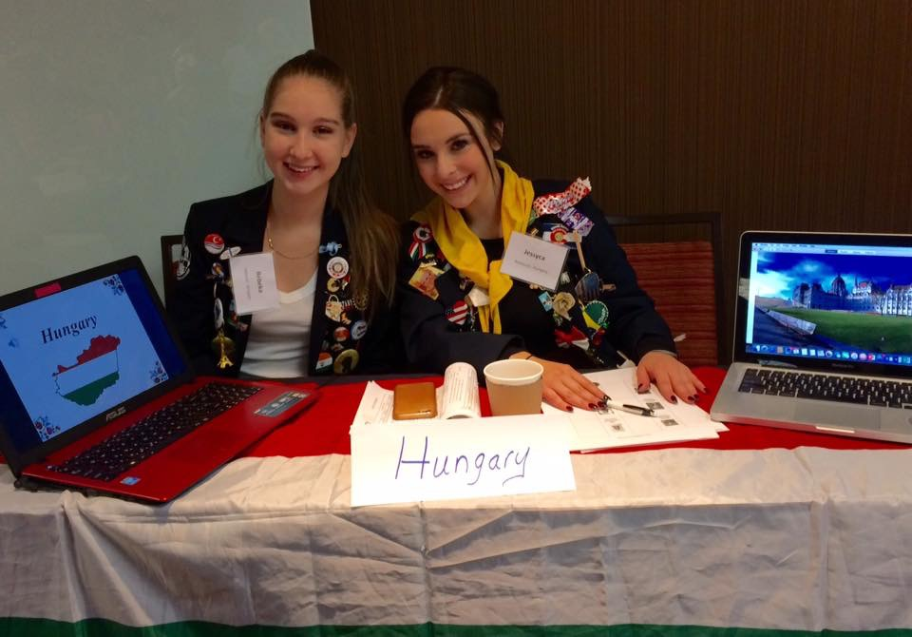

Explore the benefits of hosting a foreign high school student through Rotary Youth Exchange!
Embrace a foreign high school student into your family!
- Student attends your local high school – school expenses covered by Rotary
- Host families provide room and board and family support
- Student receives a monthly stipend from the Rotary club, and natural parents pay necessities such as clothing and medical insurance
- Share your family traditions and our American culture, and learn about theirs
- “Host families” may be empty-nesters, single parents, or those with young children
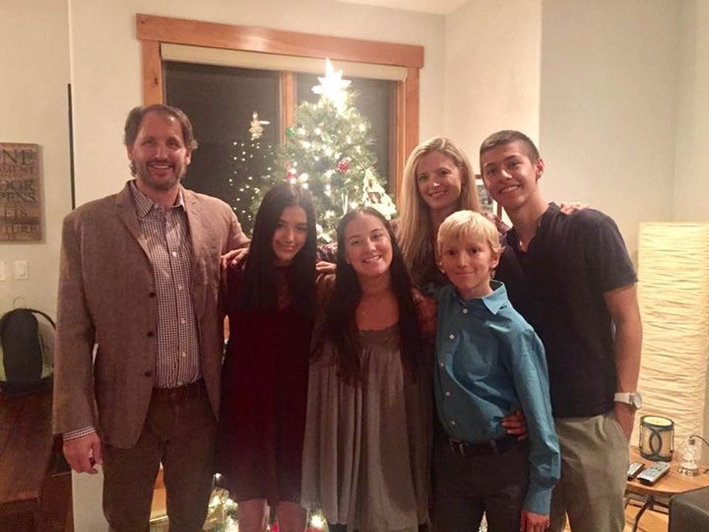
Host 3.5 - 4 months during these (flexible) timeframes:
- Early August – Thanksgiving
- Thanksgiving – February
- March – early June

Mountain & Plains Rotary Youth Exchange
www.facebook.com/mprye * http://mountainandplainsrye.com/host-families

We are accepting applications from local high school students interested in studying abroad, too! www.mountainandplainsrye.com/applicants
For further information regarding Rotary Youth Exchange, please email: kristigadams@gmail.com

